**Detailed Instructions for Methods File(s)**

The methods file template is structured to allow for collecting all types of methods into one master methods library, independent of the kind of method - e.g., sampling, measurements, sensors, preservation, data processing etc. Thus, it is totally acceptable (and even recommended) to reuse the same methods file for several or all data packages from a specific research group or project, as long as all methods used and referred to within any (meta)data files are included with enough details to meet the requirements for all relevant reporting formats.

However, to simplify things, the following instructions and examples only include information on how to structure a Methods file for methods related to the water-soil-sed-chem-reporting format. For this purpose, it is strongly recommended to use the Methods_template for your Methods file(s), as it will automatically ensure compliance with the reporting format and minimize issues with uploading your data package(s) to ESS-DIVE. Should you choose not to use the template, you will need to carefully follow all instructions and refer to the term_lists for this reporting format, as well as for those upstream of it (Sample Metadata, csv, and FLMD reporting formats). It is also strongly recommended that you discuss your method file(s) structure with an ESS-DIVE team member if you plan to deviate from the template.

Figure 1 shows examples of the minimum (top) and optional/recommended (bottom) metadata fields included in the methods file template. Note that the optional/recommended fields break out metadata that is also included in the Method_Description, but that can be useful for data users to use as basis for data searches (e.g. if looking for data from a specific type of instrument or from anoxically preserved or field moist samples).

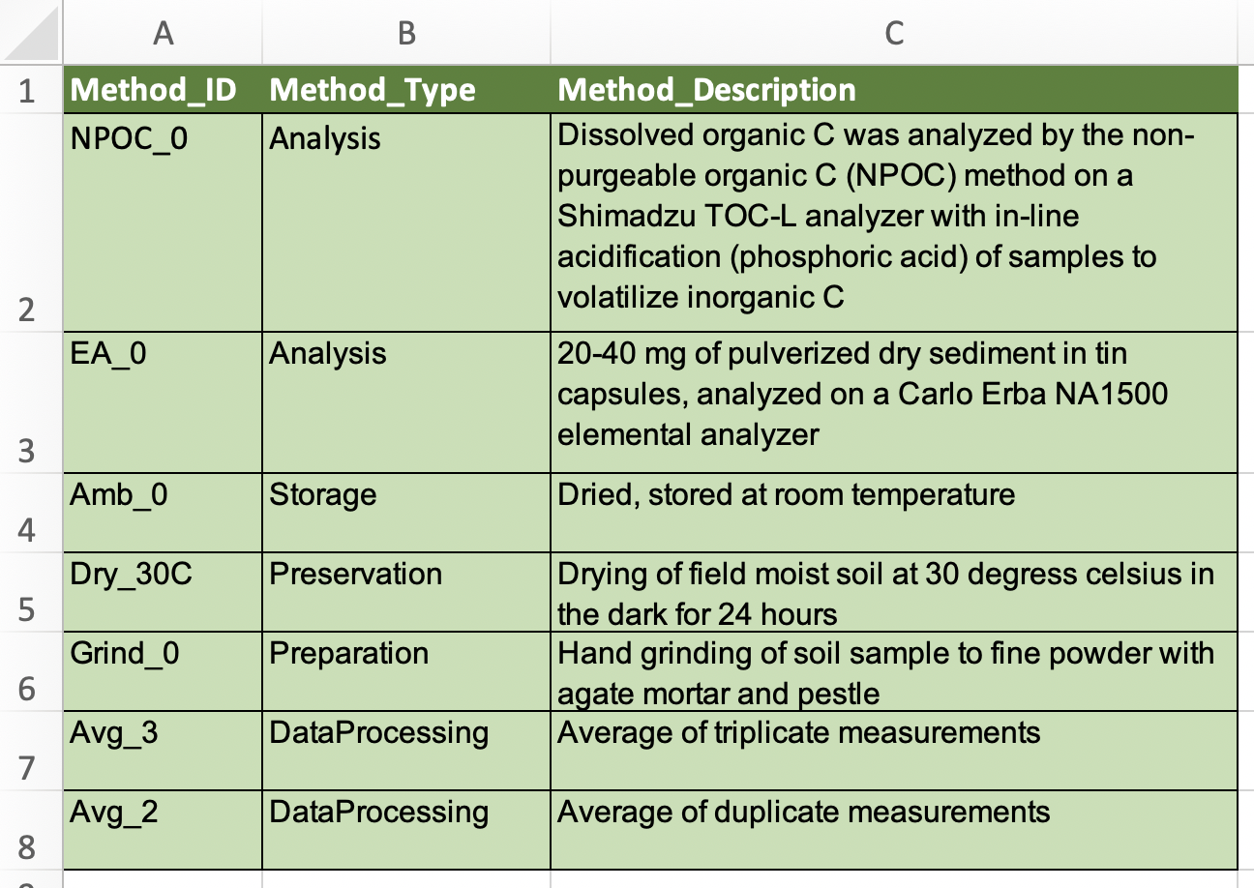

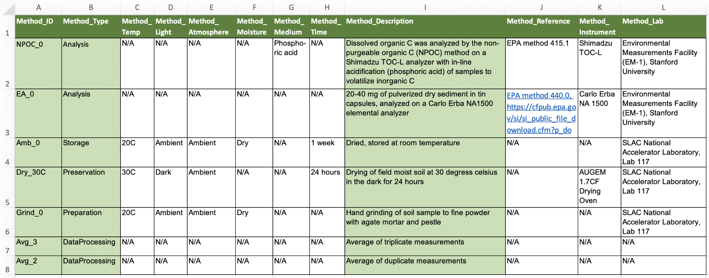

**Figure 1.** Example of methods file with only required metadata (top), and with optional (recommended when relevant) metadata fields (bottom).